1. Create a file list with the list of .txt files in which you want to run DFA, and save it in the same folder where all the .txt files are located.

The filelist should have the name of each file in a different row, all in the first column.

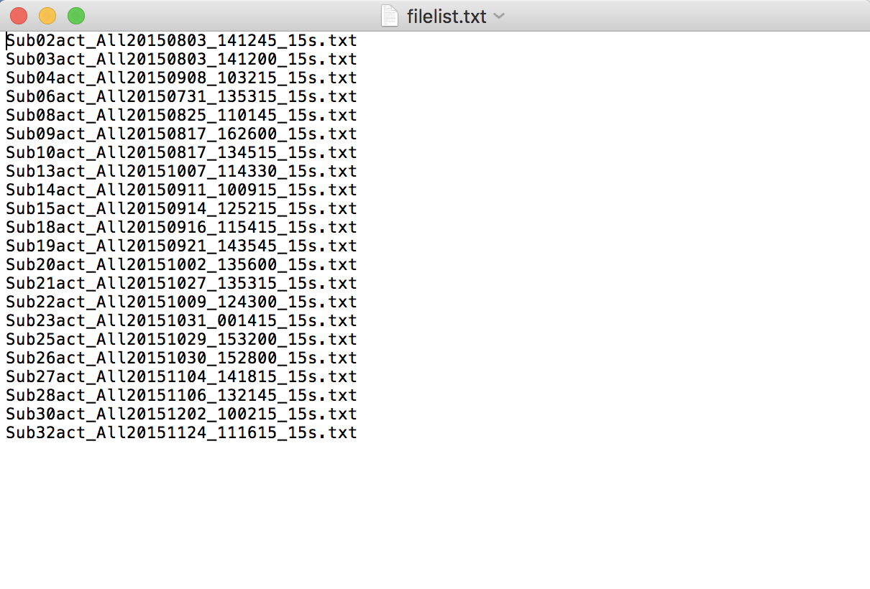

* If you want to analyze specific segments of the data, you can add a .segs column on the 2nd column of the filelist.

1. Create a .txt file with the data point range you want to analyze, separating them with a space.

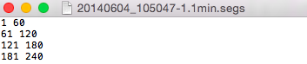

Make sure to save it with extension .segs.

1. Create a “Seg” folder where you will place all the .segs files created.
2. Now, on the filelist.txt, add a second column (separated by space) and add the .segs files on this column.

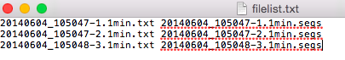

* If you want to exclude part of your data, you can add a .gaps column on the 3rd column of the filelist.

[If you want to use gaps, but not segs, make sure to leave a second column with any string (for example: xxxxxx)]

1. Create a .txt file with the range of data points that will be excluded for each file.
2. Save with extension .gaps and save on a folder called “Gap”.
3. On filelist, add a 3rd column (separated by a space) with the name of the .gaps files.

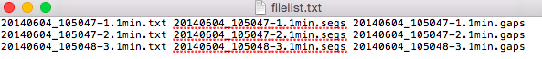

1. Open matlab
2. Run “DFATool.m”

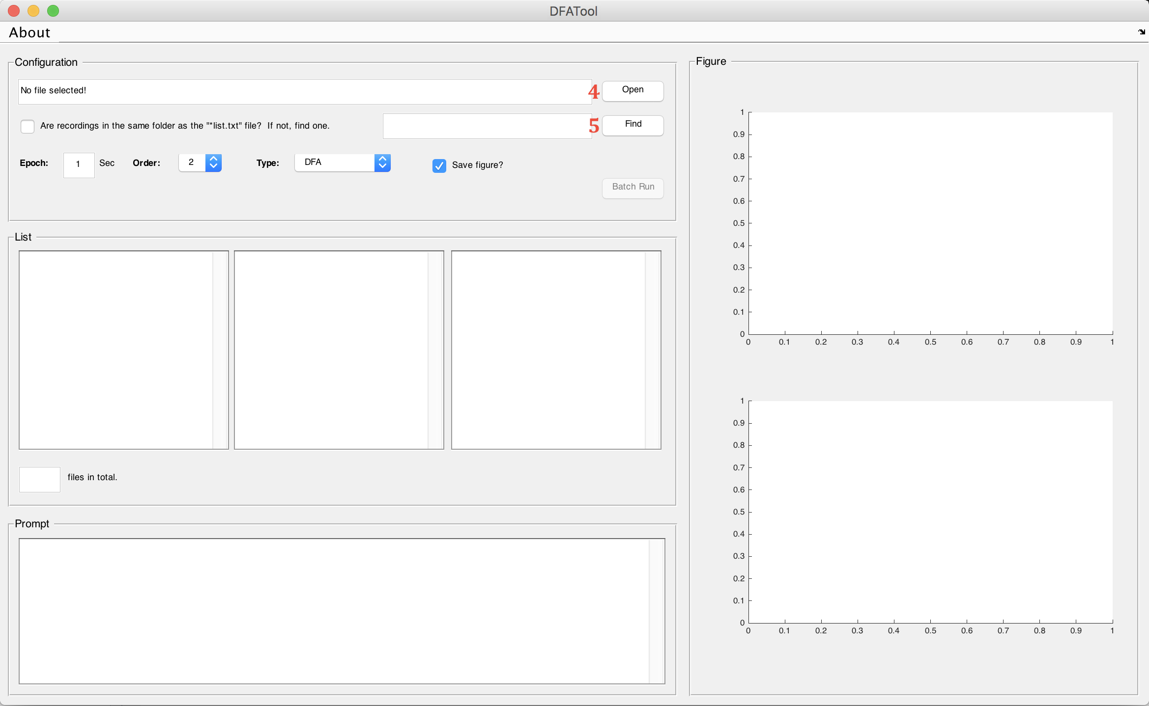

1. Select “Open” and choose the file list you created.
2. Select “Find” and choose the folder that contains all the .txt files that are within the file list.
3. Choose the epoch needed, pick Order 2 and click on “Batch Run”

This will create a Results folder outside of the folder where your data is saved. Within this folder you will find screenshots of each file (in Figure_Results) and .dfa2 files (in Numerical_Results). A “filelistdfa2.list” will be created for further use.

You can now close the window for DFATool.

1. On matlab, run “DFAFit.m”

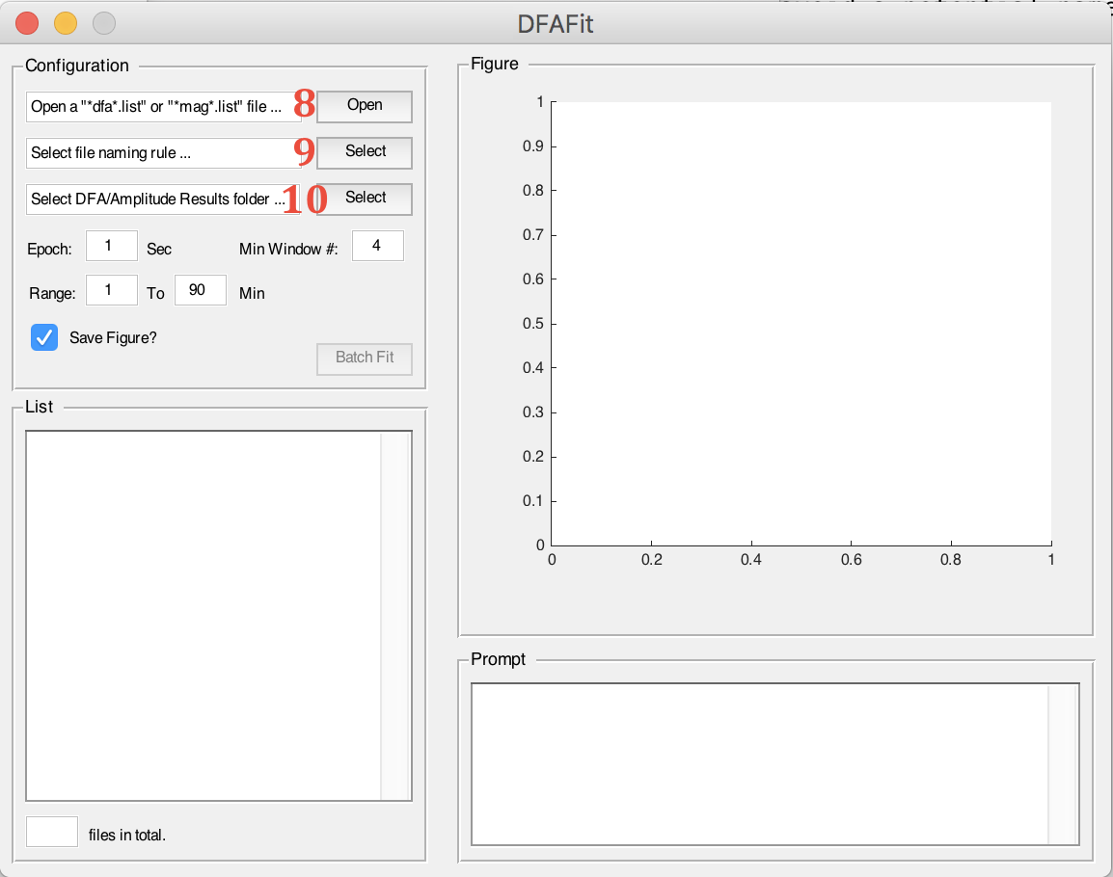

1. Select “Open” and choose the dfa2.list file that was generated from the DFATool program. It will be located within the Results folder.
2. Click on the 1st “Select” and choose the “ParseName.m” file that we gave you.
3. Click on the 2nd “Select” and select the folder where all the .dfa2 files are located (which should be Numerical_Results).
4. Choose the epoch, range and minimum window number desired, and click on “BatchFit”

Under the Results folder, this will create a .csv file with the alpha values for each file and the folder “Figure_Results” with screenshots of each file.